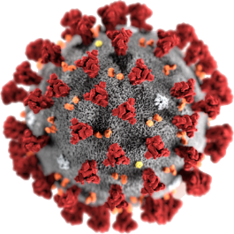

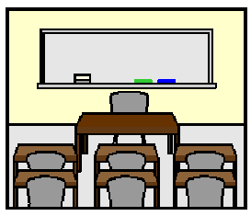COVID - 19

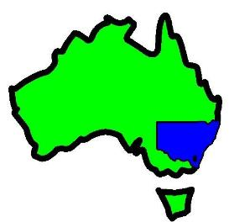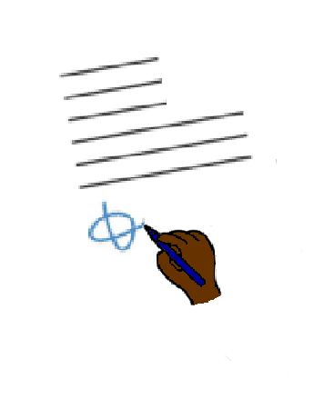

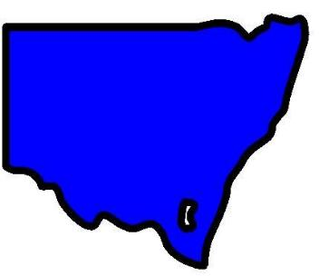

**NSW. New rules for school**

22 August 2020

**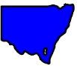****Schools in NSW only**

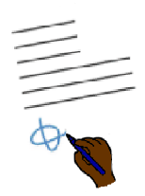

There are new rules.

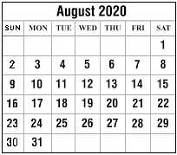

They started on 19 August 2020.



There are some things you can **not** do now.

You can **not** go to most other schools

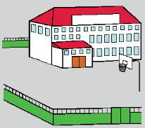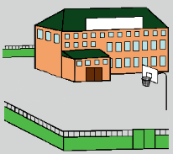

to do things. Like

* you can not go from a city school

to a country school

**or**

* a school near Manly to a school

near Parramatta.

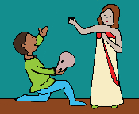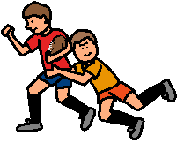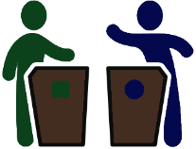

You can **not** do these things. Like

* sport
* drama
* debates.



Teachers can **not** go to other schools for training.

At your own school there must be

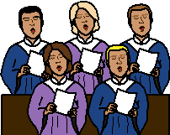

* **no** group singing
* **no** chanting.

You can **not** play instruments you blow into. Like

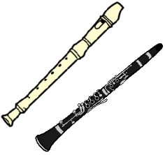

* recorder
* clarinet.

There are **no** trips where you stay overnight. Like

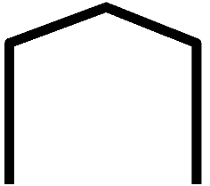

* camp
* study weekend
* leaders weekend.

All social things must **stop** for school. Like

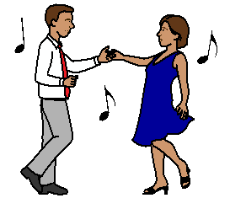

* **no** school dance
* **no** school formal



* **no** school event to say you are finished.

This may be called graduation.

* **no** parent events.

**More information**

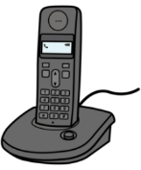

COVID - 19 information. Call 1800 020 080.

You can call at



* any time
* any day.

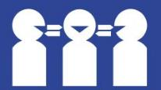Translations

Call 131 450

**Images**

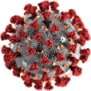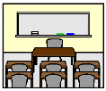We have used images from

* Freepikps
* 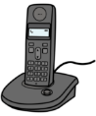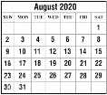Mayer-Johnson
* Picto-Selector
* PrintableCalendarTemplate
* TheNounProject.

# This fact sheet is based on the Minimising risk of COVID - 19 transmission in NSW school communities. Advice from Dr Kerry Chant. Chief Health Officer NSW Ministry of Health.

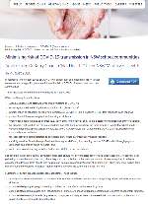

# 14 August 2020.

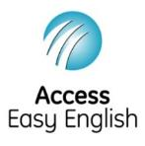Access Easy English wrote the Easy English.

22 August 2020.