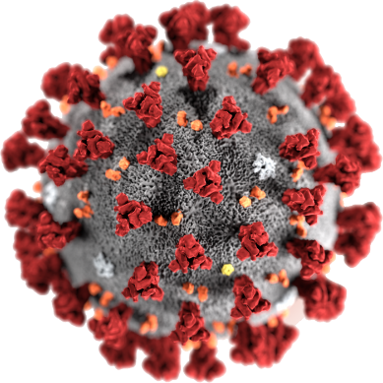

COVID - 19

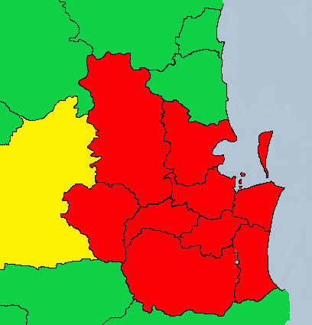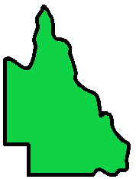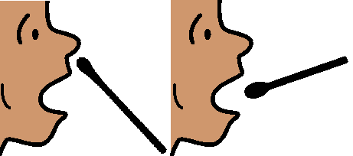

**Queensland. Toowoomba.**

**Did you go here?**

**16 August.**

**30 August 2020. 12 noon.**

There is more COVID - 19 in lots of places.

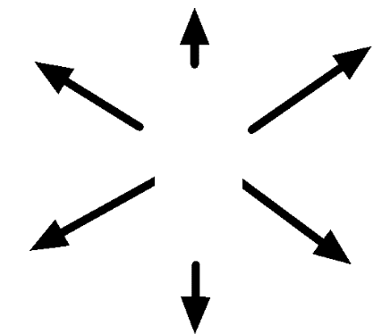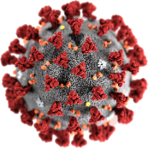

Queensland Health asks some people

to get a test.

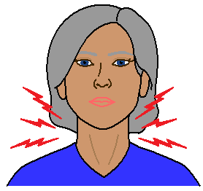

Do you have signs of COVID - 19?

Read page 5 for the signs.

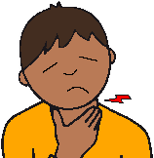You may only have a



* runny nose
* a bit of a scratchy throat.

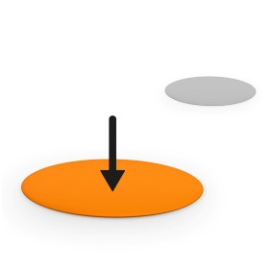**Did you go here?**

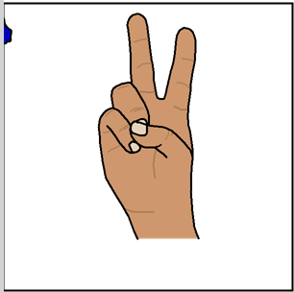

There are 2 places to check in Toowoomba.

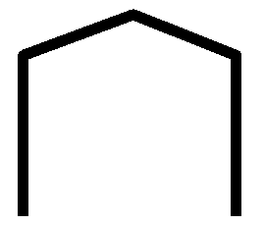

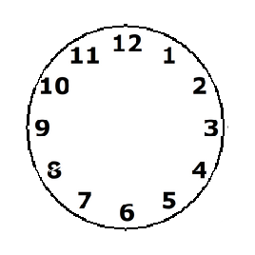Were you there at the

* same place
* at the same time?



You may need to get a test.

**Sunday 16 August**

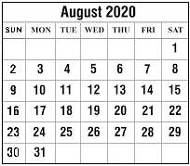

The Southern Hotel. Toowoomba.

Toowoomba.

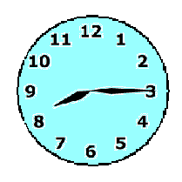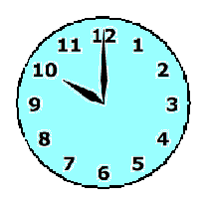

8:15 am to 10 am.

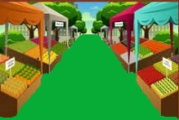Queens Park Markets. East Toowoomba.

Toowoomba.

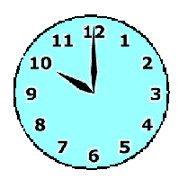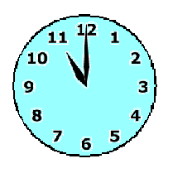

10 am to 11 am.

**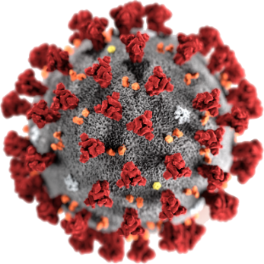****COVID - 19**

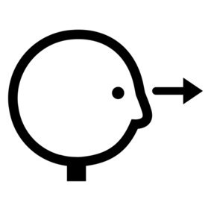

Look for the signs.

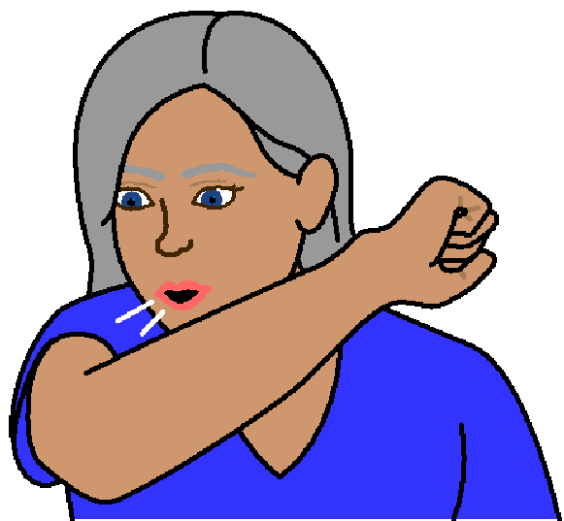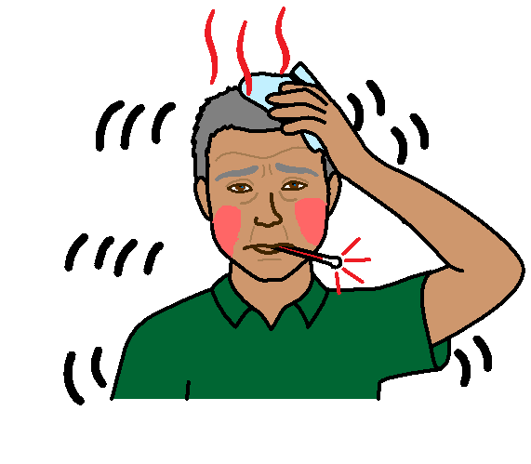

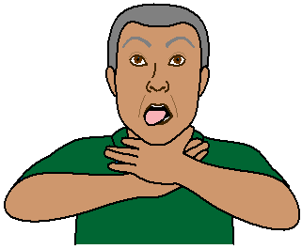

fever

red face

shivers

dry cough

hard to breathe

sore throat

**More information**

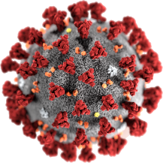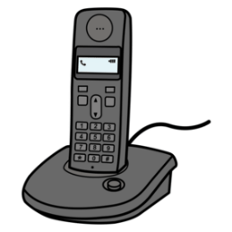

COVID - 19 information. Call 1800 020 080.

You can call at

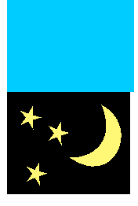

* 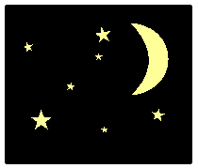any time
* any day.

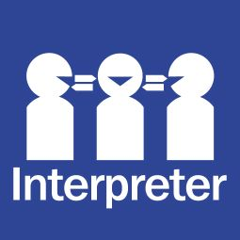Translations

Call 131 450

**Images**

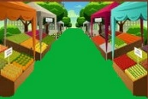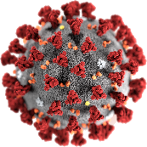We used images from

* Freepikps
* 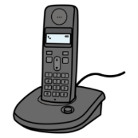Gograph
* Mayer – Johnson
* 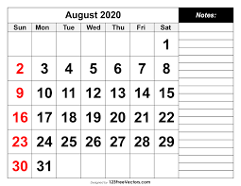Picto-Selector
* PrintableCalendarTemplate.

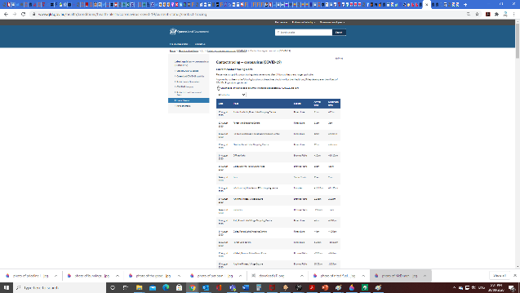This fact sheet is based on QLD Government Health alerts contact tracing. [www.qld.gov.au/health/conditions/health-alerts/coronavirus-covid-19/current-status/contact-tracing](http://www.qld.gov.au/health/conditions/health-alerts/coronavirus-covid-19/current-status/contact-tracing) at 29 August 2020 5:54 pm.

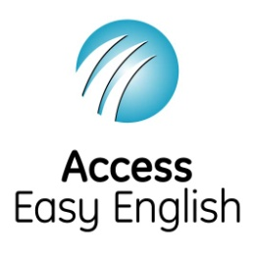

Access Easy English wrote the Easy English.

30 August 2020.