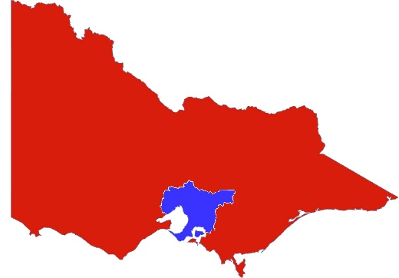

**Victoria**

**2 August 2020.**

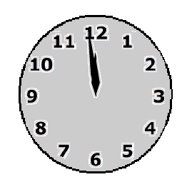

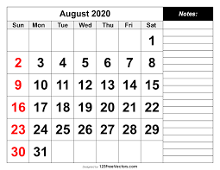

From **Wednesday** night

**5 August** 2020

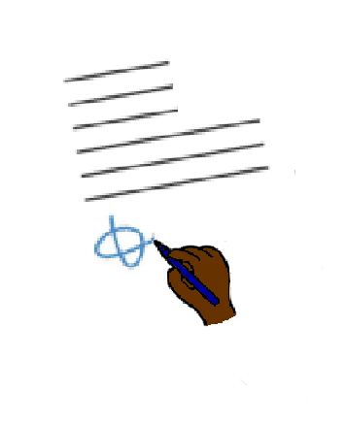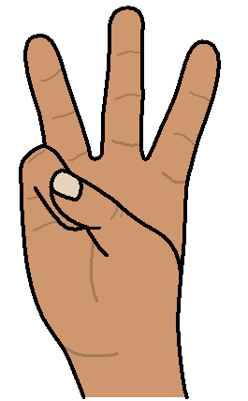

It is stage 3 shut down.

You can only go out for



4 things.



1. **To shop for food**. Like

* to go to the supermarket
* 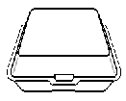to pick up take away.



1. **To go to the doctor**

**or**

To help some one.

1. 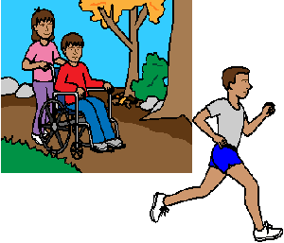**To do some exercise.**

You can go for a walk or run.

It must be

* in your local area
* by your self

**or**

* with only 1 more person.

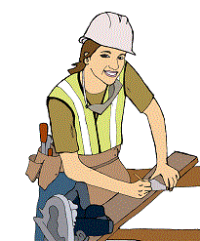

1. **To go to work.**

**But**



Only when you can **no**t work from home



Thursday 6 August 2020

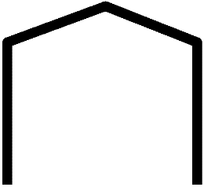

School at home starts.

Some children may need to go to school. School will be open for them.

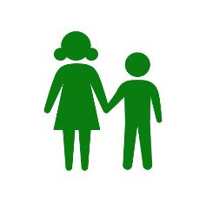

Information from [www.premier.vic.gov.au](http://www.premier.vic.gov.au) . 02/08/20. Developed by Access Easy English. 02/08/20. Australia

Images from Freepikpsd,,InspiredServices, Mayer-Johnson, PrintableCalendarTemplate, TheNounProject.