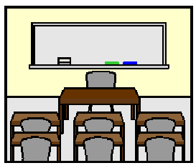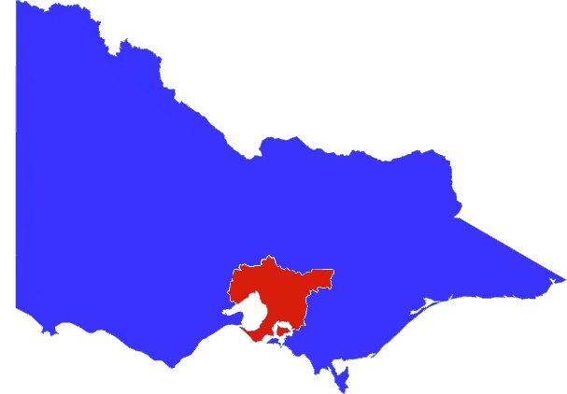

**School in Melbourne**

**2 August 2020.**

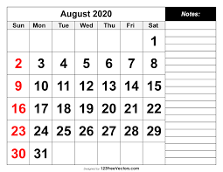

School is the same on Monday 3 August 2020.

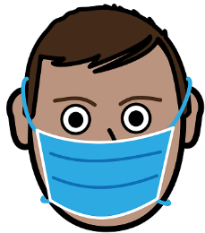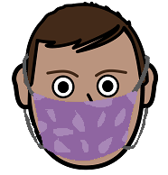

Wear your mask.



Tuesday 4 August 2020.

Only teachers go to school.

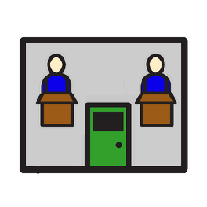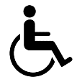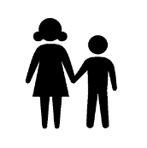

No school for

* Year 11 and Year 12

**and**

* Special School students.



Wednesday 5 August 2020.

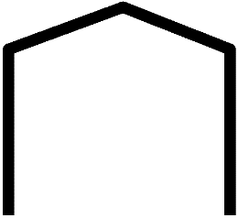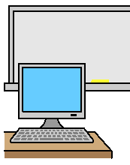

School at home starts.

Information from [www.premier.vic.gov.au](http://www.premier.vic.gov.au) . Developed by Access Easy English. 2 August 2020. Australia

Images from EasyOnTheI, InspiredServices, Mayer-Johnson, PrintableCalendarTemplate.