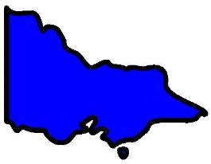**In Victoria.**

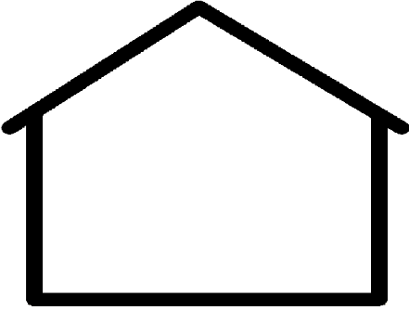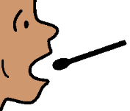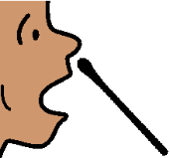

**Get a test at home.**

11 August 2020

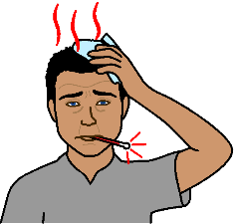

You think you have signs of COVID - 19.

Go to page 4 to read about all the signs.

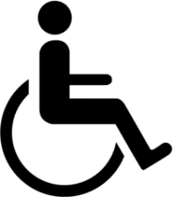

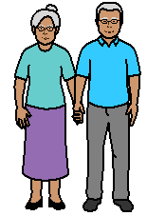You can not leave your home. Like

* you have a disability.

You can **not** get to a testing site

* you are old. It is hard to get out of home
* 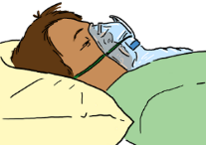you are always sick. It is not COVID - 19
* you are at high risk. You have cancer.

Developed by Access Easy English. Updated 10 August 2020. Australia

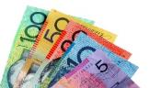You can get a COVID - 19 test at home.

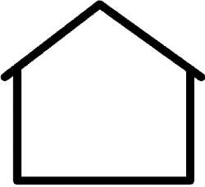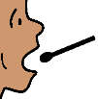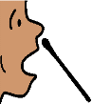

It is free.

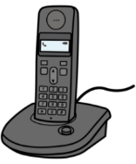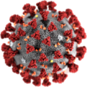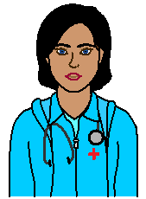

Call 1800 675 398.

You will talk to a nurse. The nurse will help work out what signs of COVID-- - 19 you have.

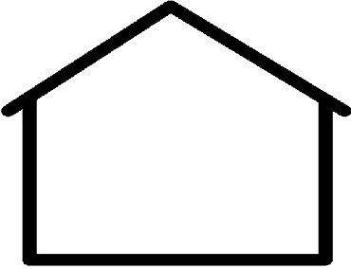

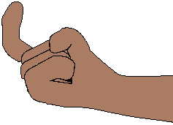

**?**

Ask the nurse will they come to your home?

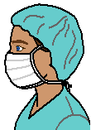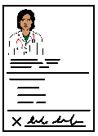

The tester will come to your home.

You need get a doctors referral.

Developed by Access Easy English. Updated 10 August 2020. Australia

You are in Melbourne.



The tester will come with in 2 days. Like ask for a test on Monday. The tester will come

* later that day

**or**

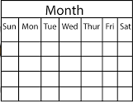

* Tuesday

**or**

* Wednesday.

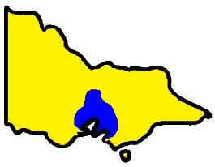

You do **not** live in Melbourne.

You live in country Victoria.

You may need to wait some more time.

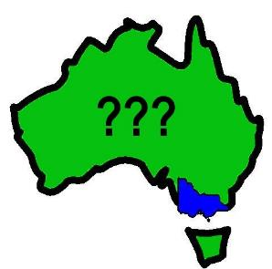

Other states may do tests at home too.

Listen to information from your state.

Developed by Access Easy English. Updated 11 August 2020. Australia

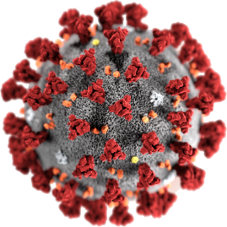

COVID - 19

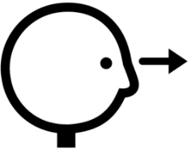

Look for the signs

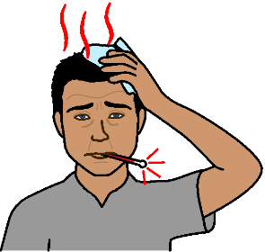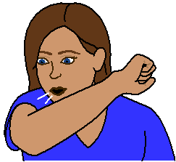

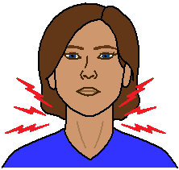

hard to breathe

sore throat

cough

high temperature

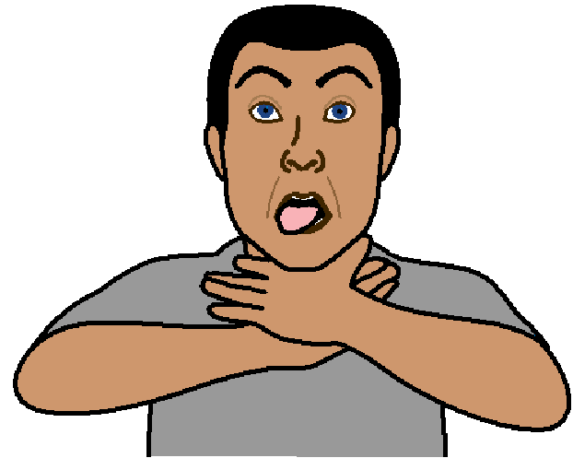

Based on the Victorian Health Minsters statement & Press conference 10 August 2020. Developed by Access Easy English. 11 August 2020. Australia

Images from Freepikpsd, Mayer-Johnson, Picto-Selector, SocialBuzz, Spectronics